

**UNDP-JTF I-Verify Portal user manual**

**Misinformation project**

**V1.2**

**Date: [14 September 2021]**

**Confidential - ICC**

|  |
| --- |
| ***Trusted shared services and digital business solutions*** |



**Table of Contents**

1. Introduction to I-Verify 4

2. Purpose of the document. 6

3. Menu and page structure 7

3.1. Main Menu 7

3.1. Footer 8

3.2. Main Page 11

4. Category management (Validation Status) 13

5. User management 16

6. Moderating comments 16

7. Post adjustments 17

8. Social Sharing 19

9. SMS and WhatsApp configuration 20

10. External Dashboard 21

**Revision History**

|  |  |  |  |
| --- | --- | --- | --- |
| **Version:** | **Who:** | **What:** | **When:** |
| 1 | Victor Benet | Initial version | 23/08/2021 |
| 1.1 | Victor Benet | Initial version | 14/09/2021 |
| 1.2 | Victor Benet | Additions of new modules | 21/01/2021 |
|  |  |  |  |
|  |  |  |  |
|  |  |  |  |
|  |  |  |  |

# Introduction to I-Verify

The I-Verify product reports the veracity of news, this is achieved by fact-checkers who check on content and produce structured reports that display the veracity of the news providing sources to back-up facts.

The I-Verify platform is made of different modules that are integrated:

* Meedan is the center piece: is a SaaS product that enables fact-checkers to act on articles arriving to them. These articles can come from different sources.
* The Triage bot:
  + The Triage bot reads content Crowdtangle, a public tool from Facebook that allows collecting of posted content and based on specified set of filters and how it is being shared.
  + The collected information is then processed through an AI open-source algorithm, to get an indicator on toxicity. Human fact-checkers will access Meedan and review the information to contrast and validate it finally, indicate if it is valid or fake news.
  + Currently I-Verify supports the following algorithms to tag the content:
    - Detoxify
    - Diagram

      Description automatically generatedPerspective
* The publishing process use a WordPress site that receives the reviewed and categorized information for the public user. The solution also integrated many additional plugins, some of the common in WordPress based portals.
  + The plugin base includes:
    - Integration with MailChimp, to distribute digest newsletters
    - Diagram

      Description automatically generatedThe capability to send SMS and WhatsApp messages through Twilio, using WPNotif.
* The solution also offers an integrated dashboard to show indicators by source channel, information tag, process and timeframes.
  + Chart

    Description automatically generated with low confidenceThis dashboard is integrated with WordPress Authentication.
* The CSV reporting channel, a bot that on a daily basis sends the article annotation, thus the article content and all their associated metadata, in CSV format by email, this can be shared with major online media to flag toxic or hate-speech articles being published.

# Purpose of the document.

The aim of this document is to deliver a user manual for the admins of the I-Verify Portal, covering:

* Menu and page structure
* UI adjustments
* Post adjustments
* Category Management
* Comment Moderation
* User management
* Newsletter settings
* SMS settings

# Menu and page structure

All site pages are composed of a header and a footer that is common. Both elements have certain configurable regions:

## Main Menu



It is configured in under “Appearance -> Menus” in the WordPress administration panel.

Then select Main menu, as highlighted in the image below:

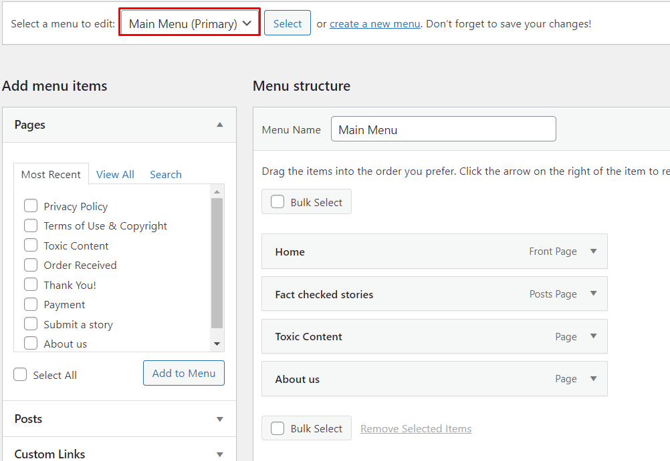

The different elements can be edited, you can also add or remove elements at your will.

Static pages are easily added by clicking on “Add to Menu” on the left-hand side, once you select the items you want to add.

You can also link:

* A category page, that will list all the posts under that category
* A given post
* An external link (using custom links)

To remove a link from the menu, click on the item and it will expand to show the options with it:

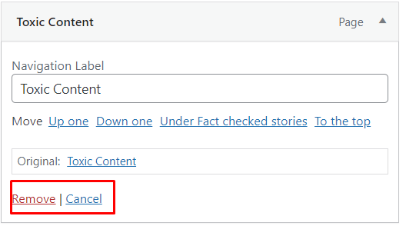

Then click on remove.

**Remember to click on Save Menu on the bottom-right corner to have your changes always saved.**

## Footer

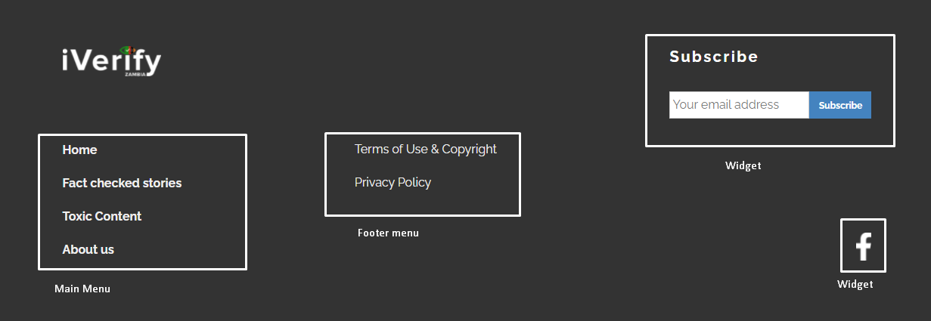

In the footer we see:

* The main menu
* The Footer Menu
* And two widgets, one to subscribe to the newsletter
* The second one to display social media icons.

**Edit the footer menu**

As in the previous scenario, go to Appearance à Menus, select “Footer Menu – Left”

Originally the site was conceived to have two menus in the footer.

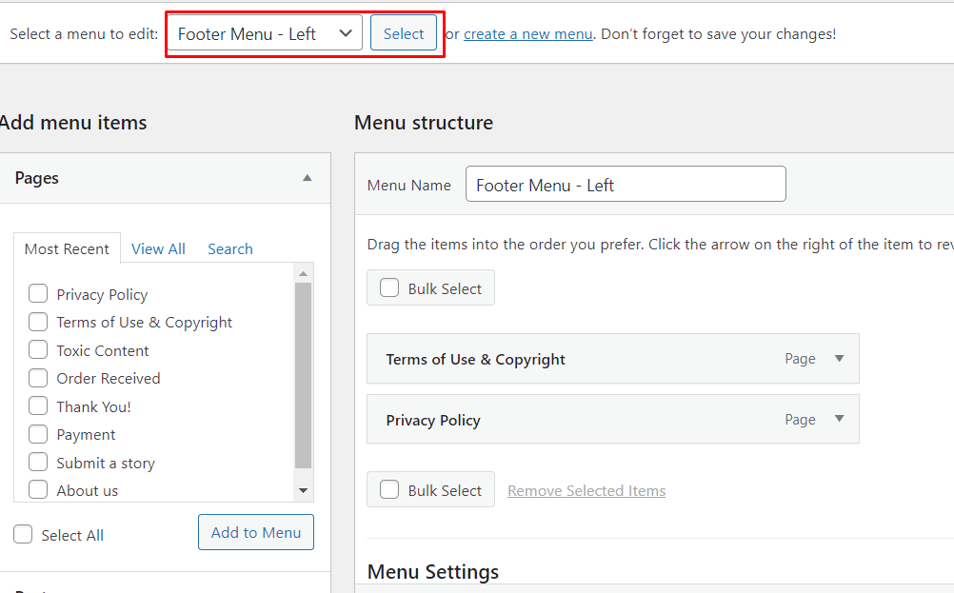

**Edit the widget – Newsletter**

Under Appearance à Widgets, look for the following widget: “Footer Sidebar Right”

You will see that the widget refers to a form made with MC4WP plugin, (Mailchimp for WordPress):

* The details of the form can be found on the following link:

<https://iverify.org.zm/wp-admin/admin.php?page=mailchimp-for-wp-forms&view=edit-form&form_id=569>

The WYSIWYG editor will allow you to modify the appearance and fields of the form, but this will impact the site UI and we discourage you from doing that

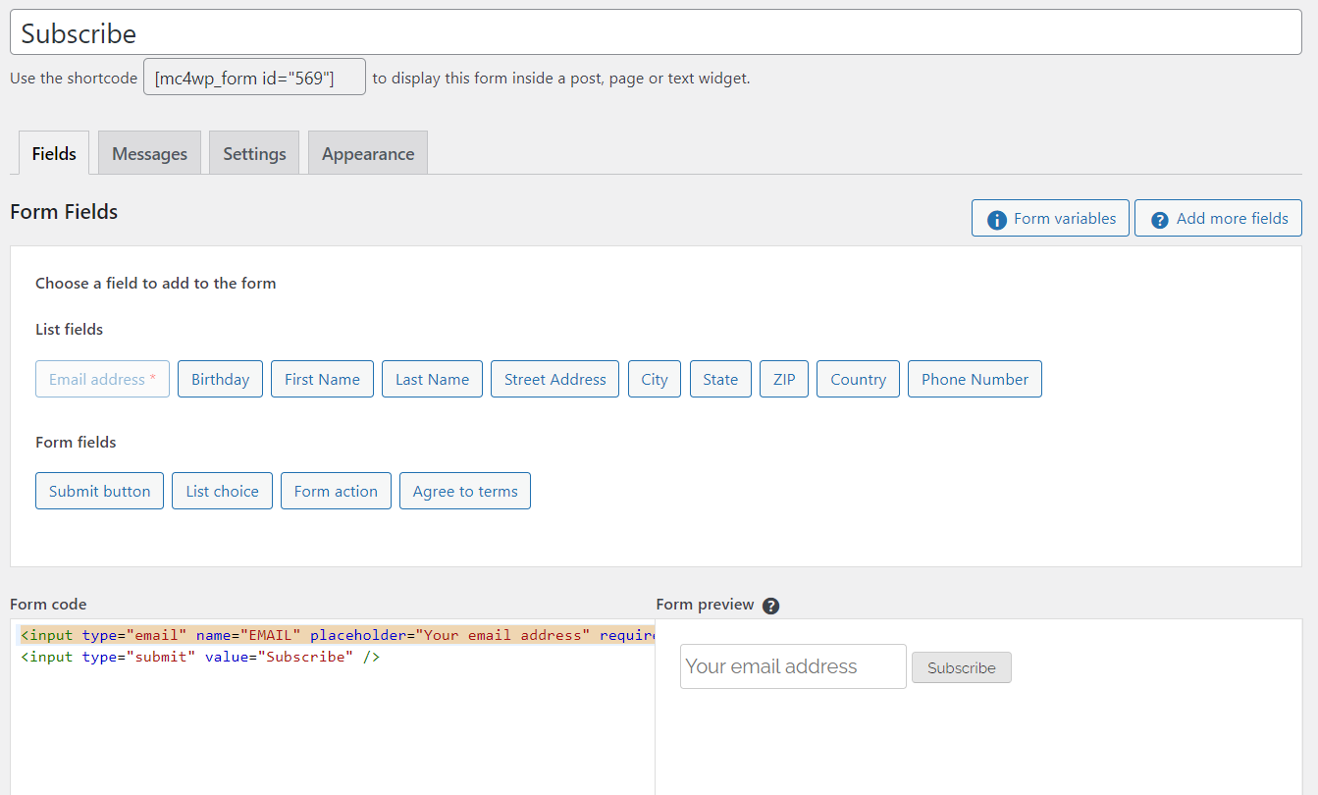

**Edit the widget – Facebook**

Under Appearance à Widgets, look for the following widget: “Footer Sidebar Right”, same as Subscribe.

On the white area, highlighted in the image below, click and select “HTML”:

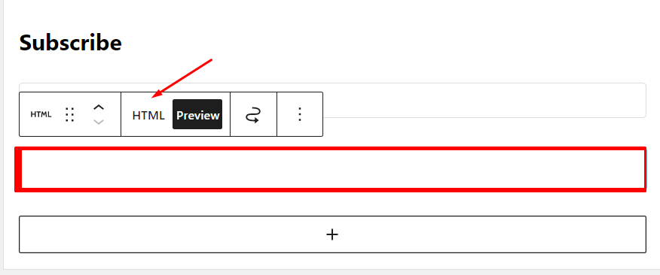

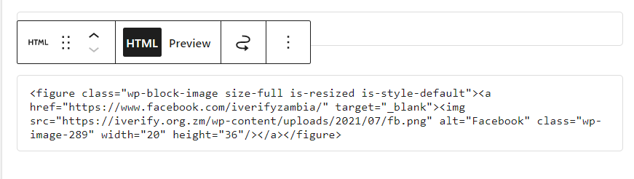The code will appear. You can add new links, just upload first the images to the media library, ensuring they are white, and background is transparent and with a size of 20 X 36px

Copy the block replacing the section highlighted in red with the link to your new image, and the URL highlighted in blue, with the new URL:

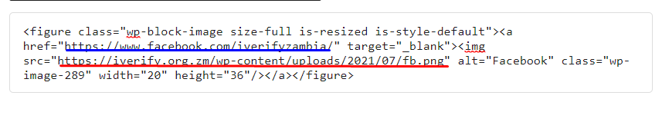

## Main Page

### Trending topics



The main page trending topics can be adjusted as needed from the admin panel.

To do it, go to Pages à All pages and edit the “Home – Front Page” page

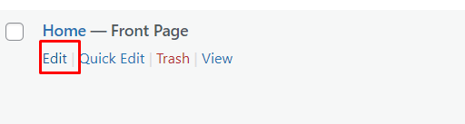

Then select the keywords from the Tags by checking the checkboxes.

**TIP: from time to time, review the tags, so you can consolidate some of them as they can be repetitions of the same, when you delete tags remember to review the blog posts and re-tag as needed, example:**

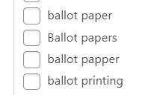

### Most Popular Fact-Checks

Click on the section “Most Popular Fact-Checks” and a side panel will appear:

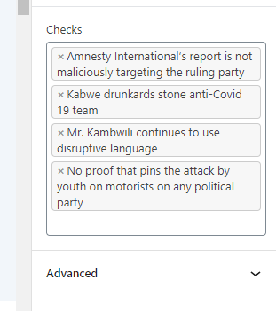

Select the items you want to be displayed as featured, by clicking on the text area. A drop-down will appear listing all the articles.

### Partners

Create or edit the partner pages on the site panel, under Partners à All partners

Then on the home page edition, as we so in 2.2.1, scroll down till you see the section “Our Partners”:

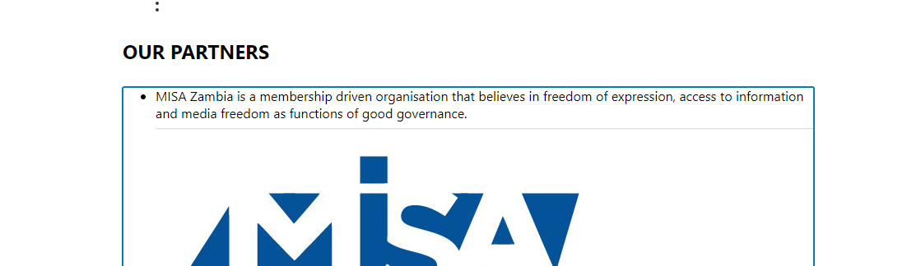

Click on it and on the right-hand side, you will be prompted a menu:

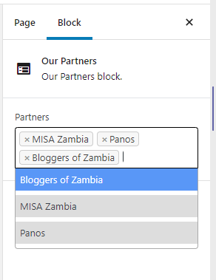

The image above already displays those 3 partners are selected (with an ‘x’ before the partner’s name) and there are three partners as partner pages.

# Category management (Validation Status)

The categories are used to determine the validation status of every story.

It is important that the category name is the same in Meedan and in WordPress, else the blog post will not be created.

Go to Posts and then click on categories:

* To add a new category, fill in the fields in the form:

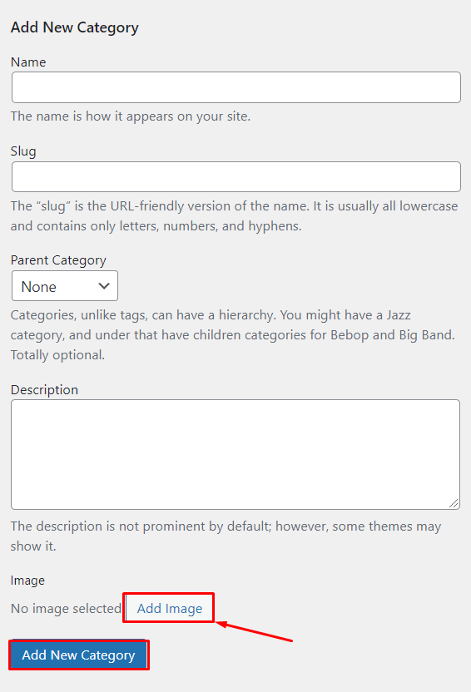

Do not forget to add an image for the category. Then click on Add new Category.

To edit an existing category, hover your mouse on the category you want to edit and click on the ‘Edit’ link.

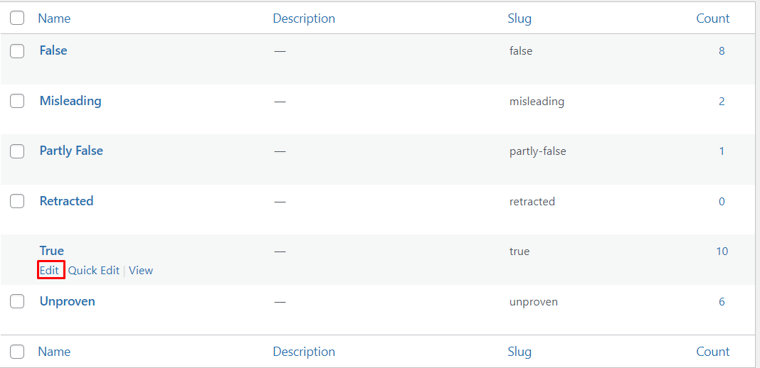

You may need to align the legend of the categories after any change (images, name…)

Go to appearance, then go to widgets. Find the “Single Post Sidebar”.

Click on it to edit:

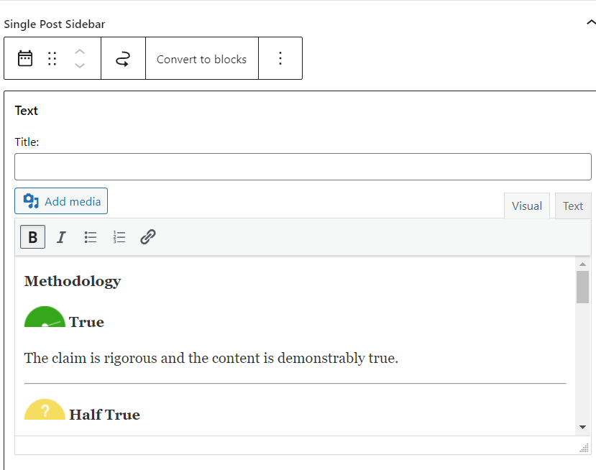

Change the images and the text as required. You can also append new blocks.

# User management

General recommendations of user management.

* You have been given administrator accounts, be sure to change the password with frequency and deactivate accounts if and when required.
  + Review on the user management, under Users à All users, the last time each user logged in, if it is more than three months you can deactivate the account.

* Phone number is needed in case you want to set SMS functionality:

* Once the environment has been handed over, ensure that UNICC member accounts are disabled, unless there is a Service Delivery Agreement that justifies them having an account.
* Try to limit the amount of people having Administrator role, explore the other roles in WordPress and adjust as needed.
  + Most of the time should be enough with Editor permissions
  + You may consider Authors to create content aside of Meedan.

Information on WordPress roles and capabilities: <https://wordpress.org/support/article/roles-and-capabilities/#capability-vs-role-table>

# Moderating comments

Users can contribute to the site adding stories that have been created using the site articles. To prevent spam, two measures have been set:

* Akismet plugin is installed, this tags as spam comments in case they are, so reduces the number of comments to be reviewed.
* Comments are moderated, they do not publish unless someone approves.

When logged in you can check if there are new comments by looking at the top bar or at the side menu panel:



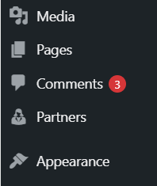

Click on the comments to see them.

Each comment should have:

* An author (name),
* a story name,
* and a story hyperlink

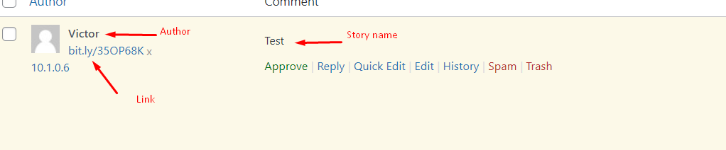

You can see the actions:

* Approve: will make the comment visible under the article
* Spam: will mark the comment as spam
* Trash: will send the comment to the trash

You can also remove the approval a comment that was previously approved.

# Post adjustments

Post adjustment can be done in Meedan, and the changes will be reflected in the WordPress portal. That is the recommended way to adjust a blog entry. However, it is still feasible to use the WordPress editor for that purpose.

Just remember that the post structure is not the default WordPress one, the following image should help you understanding the post structure and the related fields.

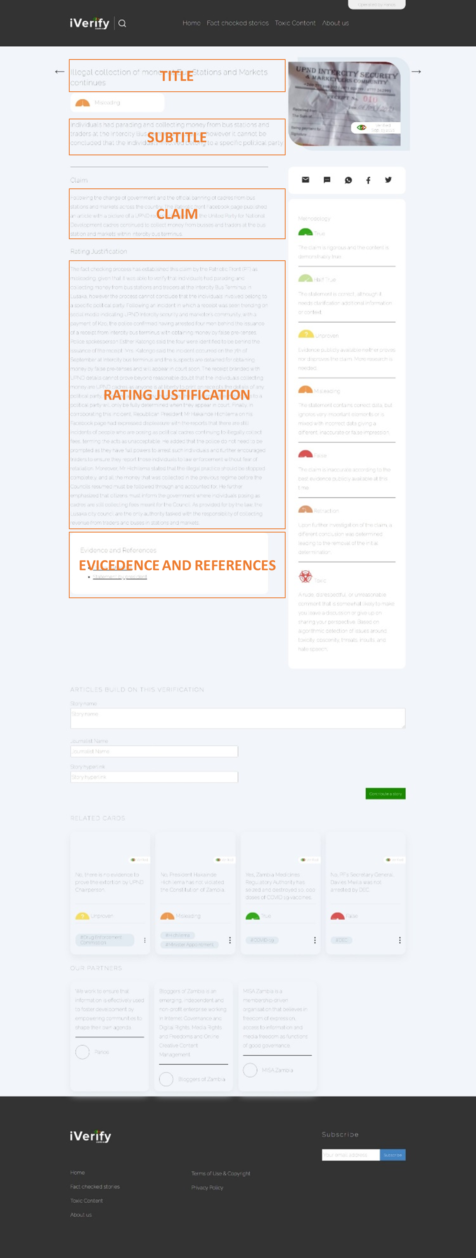

# Social Sharing

The social sharing options can be also edited at any time. The configuration is made by adjusting the settings of All-in-One SEO plugin.

The sharing settings have been set as follows:

* Under AIO SEO settings, go to Social Networks, then select the network to edit.
  + Enable Open Graph Markup
  + We consider that a post can come without a feature image, in case it is forgotten in Meedan, for that case a default illustration was added
    - Filename: placeholder-featured-image.png
  + The card will show the featured image of the post and a short text message that follows this structure:
    - Static text: “I found something interesting in iVerify” (or its Spanish equivalent)
    - Followed by post title
  + The following screenshot shows the adjustment:

# SMS and WhatsApp configuration

This feature requires a valid account in an SMS gateway, we are using WPNotif, any supported gateway in WPNotif can be used. For demonstration purpose we will show the settings for a Twilio SMS Trial account.

In the left menu, access WPNotif, then click on settings.

* Select the option for Twilio under SMS, and type in the Account SID, Auth Token and Sender ID.
  + These can all be gathered from the Twilio panel:

* For the trial account to work, you need to access your Twilio account and add the people:
  + Access in Twilio the list of verified numbers.
  + Add the numbers of the people you want to receive messages:

* + These numbers should match the user phone number in WordPress, when setting users, check their number is set and that it matches the one in Twilio.
* If the set of users you want to receive the SMS does not match any of the default ones, create a new group under User Groups in WPNotif and add the users.
* To set-up the notifications go to Settings -> Notifications. The default configuration includes adding a notification each time a new entry is added. The message can be customized, but beware of SMS message length limit, usually 160 characters.

# External Dashboard

Integrated with WordPress login, hence any user created in WordPress would have this feature available, is the Dashboard.

The access to the Dashboard can be found as the top entry on the left-hand side menu:

